https://students.ashworthcollege.edu/

Username: Carriegilles@ymail.com
Password: 133Angelina!!

Once you login in, if you scroll down in the center, it says courses, then click on Geometry: Part 2

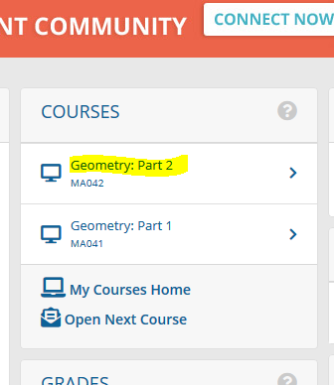

It will then bring you to a Homepage. Click on the assignment tab and then quizzes.
It will be the Final Exam all the way at the bottom

